**Trinity United Church of Christ**



***February 2025***



***Worship: 9:00 AM***

**-----------------------------------------------------------------------------------------**

**Communion: Please pick up your communion wafer and cup as you enter the sanctuary.**

**Offering: Please place your gifts in the offering box as you enter or leave worship.**

**Contact Information**

**Pastor: Mark McDaniel**

**Phone:** 812-583-3508

**Email:** [pastormark98@gmail.com](mailto:pastormark98@gmail.com)

**321 W. 8th Street … Jasper, Indiana 47546**

(Corner of Clay & 8th Street)

**Mailing Address:** P.O. Box 386 Jasper, 47547

**Office Phone:** 812-482-4090

**Office Email:** ***trinityofficejasper@gmail.com***

**Office Hours:** Monday, Wednesday & Thursday

9:00am – 1:00pm & 2:00pm – 3:00pm

**Website:** htps://www.trinityjasperucc.org

**YouTube:** Trinity UCC Jasper IN



**Monthly Calendar**

**SU 2** 8:45 am Gather & Sing Choir

9:00 am Worship & Communion

10:15 am Men’s Fellowship

**M 3** 6:30 pm Property Mtgat Parsonage

**W 5** 7:00 pm AA Meeting

**F 7** 7:00 pm AA Meeting

**SU 9** 9:00 am Worship

10:15 am Women’s Guild

**M 10** 7:00 pm Church Council

**W 12 Church office closed today.**

7:00 pm AA Meeting

**F 14** 7:00 pm AA Meeting

**SU 16** 9:00 amWorship

**M 17 Presidents Day – church office closed.**

**T 18** 4:00 pm Sunset Extension

**W 19 Church office closed today.**

7:00 pm AA Meeting

**TH 20** 9:30 am Mommy & Me Playgroup

**F 21** 7:00 pm AA Meeting

**SU 23** 9:00 am Worship

**W 26** 7:00 pm AA Meeting

**F 28** 7:00 pm AA Meeting

**SU 2** 9:00 am Worship & Communion

**M 3** Pastor Elisabeth’s first day!

**W 5** **Ash Wednesday**

7:00 pm Worship & Communion

**Pastor's Message –**

**So This Is Christmas**

So this is Christmas

And what have you done

Another year over

And a new one just begun

And so this is Christmas

I hope you had fun

The near and the dear ones

The old and the young

A very merry Christmas

And a happy New Year

Let's hope it's a good one

Without any fear

And so this is Christmas

For weak and for strong

For rich and the poor ones

The world is so wrong

And so happy Christmas

For black and for white

For yellow and red ones

Let's stop all the fight

And so this is Christmas

And what have we done

Another year over

And a new one just begun

John Lennon

This particular song has always been a downer for me. Especially the line *“So this is Christmas, and what have you done? Another year over, and a new one just begun.”* It has made me reflect upon the previous year, and it has left me feeling guilty over all the things I meant to do, but didn’t get accomplished. Maybe guilt is too strong a word – maybe remorseful or regretful. Anyway, it hasn’t given me the sense of accomplishment that I so badly desired.

I didn’t reread Calvin’s Institutes of the Christian Religion. I didn’t begin an exercise regimen. I didn’t lose the weight I wanted to lose. I didn’t begin the book I wanted to write. I didn’t keep up with my journaling. I didn’t reconnect with old friends and relatives that I haven’t spoken to in years. I didn’t…I didn’t…I didn’t…

As I wallowed in my own self-pity, it occurred to me that this had become an unhealthy pattern in my life. Being my own worst critic, it was easy for me to beat myself up. Maybe it was time to begin to lift myself up. Not to the point of arrogant pride, but to find a balance between what I hadn’t accomplished, and what I had accomplished.

When I began to reassess my year, and all those previous years, a new pattern seemed to reveal itself. I realized that those things that I did to glorify God, or for the sake of God, or with the understanding that I couldn’t have accomplished it without God, were accomplished. It was those things that I tried to do on my own, under my own power, and perhaps even for selfish reasons, were the things I didn’t accomplish.

*“I can do all things through him who strengthens me.”* Philippians 4:13 (NRSV)

Here we are, one month into the New Year. The slate is wiped clean. We have a chance to begin again. As you face the New Year, I encourage you to refocus your energies on those things that will honor God. That will be my goal, as well.

Blessings,

Pastor Mark

**Greetings from Pastor Elisabeth**

It is with great anticipation and excitement that I look forward to beginning God’s ministry at Trinity United Church of Christ. I hold fond memories of our first shared worship on November 17th. I recall the warm welcome and the vibrancy of the Trinity community filled with the Spirit’s Presence.

Monday morning, March 3rd is my first day, and then two days later—on Ash Wednesday—we will come together for worship to begin the Season of Lent.

Ash Wednesday gets its name from the ancient tradition of ashes placed on the foreheads of the faithful with these words from *The Book of Genesis*: “Remember you are dust, and to dust you shall return.” May our Lenten journey be one of meaning drawing us closer to God.

In closing, I give my heartfelt “thank-you” to all of you who have worked (and are working) to ready the parsonage for my arrival. It’s a beautiful house! I look forward to calling it home.

**In God’s Love**,

~*Pastor Elisabeth*

**PASTOR ELISABETH ARRIVING SOON**

**From Susan McGovren, Search Team member**

The time is growing near when we welcome Pastor Elisabeth. Her move in date, weather permitting, is Wednesday, February 19th. It is an exciting time for our congregation and for her.

I found these ideas to help us prepare for this transition. (From *50 Ways to Welcome a New Pastor* by Lewis Center)

1. Pray for Pastor Elisabeth as we continue to pray for Pastor Mark as he completes his service with us.
2. Send Pastor Elisabeth a heartfelt welcome note or email. A brief note introducing yourself and your family would be helpful to her.

([elbaer@gmail.com](mailto:elbaer@gmail.com) 5800 Ford Rd N, Mt. Vernon, IN 47620)

*Move-in day*

1. Have a small group on-hand to greet her.
2. Stock refrigerator and pantry with staples.
3. Provide food for the first few days.
4. Give gift certificates to favorite restaurants.

*Help her become familiar with the congregation*

1. Wear name tags. These will be located in the Narthex for easy access.
2. Introduce yourself to Pastor Elisabeth repeatedly. You have one name to learn; she has many names to learn.
3. Have an appropriate person offer to go with her for introductions and support when she visits members.

(from *10 Suggestions for welcoming a new pastor* by Barry Howard)

*Embrace the uniqueness of your pastor*

Your pastor has a distinct personality, a unique set of spiritual gifts and a diverse set of experiences. To compare your new pastor to any other is to disrespect the Spirit’s role in guiding you to your new pastor in the first place.

*Be prepared to follow*

A pastor who is worth his or her salt must lead in both optimal and challenging situations. The kingdom of God is enriched when we as a congregation follow our pastor and embrace our mission with enthusiasm.

As church members, we are privileged to co-labor with Pastor Elisabeth in demonstrating grace, sharing the good news, and equipping disciples.

(Pastor Elisabeth will lead us in worship on Ash Wednesday, March 5th and Sunday worship on March 9th.)





**Corrine Clark** *Legacy Living (812-482-3482)*

*1850 IN-56, Room #202*

*Jasper, IN 47546*

**Sherry Malone** *660 Rumbach Ave, Apt. #322 (812-582-2721)*

*Jasper, IN 47546*

**Janice Sunderman** *Legacy Living (812-559-0560)*

*1850 W State Rd 56, Room #134*

*Jasper, IN 47546*

**Shirlene Dreher** *376 St. Charles Street (812-634-1699)*

*Jasper, IN 47546*

**David Fischer** *Serenity Springs Senior Living at Northwood (812-559-1728)*

*2515 Newton Street, Room #403*

*Jasper, IN 47546*



**Pray without ceasing…**

* *Pray for ALL in need of healing; may God grant them strength and patience.*
* *Pray for those impacted by the devastations from wind, fire & water.*
* *Pray for our military, first responders and those in law enforcement.*
* *Families grieving the loss of loved ones, family members and friends.*
* *Those who struggle financially and emotionally because they do not have enough of basic human needs, especially those in this community.*
* *Those who are awaiting answers that can change their lives.*

**If you or someone you know is in need of prayers, please call or email the church office.**

 **Mission Alive at Trinity**



**Adopt-A-Family: We received this note from our 2024 Adopt-A-Family.**

**Year-to-date: $44.00**

December 21, 2024

We have been very thankful & blessed to have the help of the wonderful people of the church. We couldn’t have been more grateful to have the help. It was very comforting, and being able to spend some extra time with the children making small memories means a lot to us. With 5 small children life can get very hectic but the help we had we were able to take a step back and enjoy. The move and tornado and whatnot was very stressful, but we are very blessed & lucky to be able to come out not hurt. We the Friedman’s are very once again grateful and very thankful to have had the help of all you wonderful people. And anytime we can spread kindness or help anyone we will! Happy holidays & God bless from us to you!

God bless,

The Friedman’s & Kids

**Thanks to the entire congregation for supporting this family in 2024. Mom disclosed to the Outreach team they are now out of debt thanks to our help.**

**With gratitude, Outreach Ministry**

**Community Food Bank Updates**

The Trinity UCC family is continuing to do great work in our community. In December, we donated 39 broths/soups. In January, we have collected 81 rolls of toilet paper, 10 boxes of pasta, 2 boxes of cereal, 4 jars of spaghetti sauce, and 2 boxes of crackers. As always, your generosity and continued support for this mission is greatly appreciated.



**February item: Pasta & Spaghetti Sauce**

**Community Food Bank Updates**

A note from the Dubois County Community Food Bank:

Trinity UCC, thank you so much for your 2024 donations to benefit the Community Food Bank. We could not help the needy without the help of the community, and Trinity is a true example of that.

**2024 Total Donations: $2,000**



***“And when we take your gifts to those who need them, they will thank God”***

***2 Corinthians 9:11***

***BLANKET THE WORLD IN LOVE***

Our Outreach mission for February is Blankets of Love sponsored by Church World Services. CWS reports that blankets were distributed in 15 states and 49 agencies serving the US & Worldwide to victims of natural disasters, refugees, or to serve as bedding in shelters, or those who are unable to meet basic needs living without shelter. This year even more families suffer from disasters and displacement. Your $10.00 can provide a blanket that will provide warmth and shelter, comfort and privacy, healing and hope, wherever God’s people need care. Along with your donations goes our prayer that by sharing these blankets God’s love will be spread far and wide. Donations can be put in the marked envelopes in the pews or into your regular giving envelope noted that it is for Blankets of Love. Thank you for your generosity so we can *Blanket the World with Love.*

**GOAL $500 (50 Blankets)**

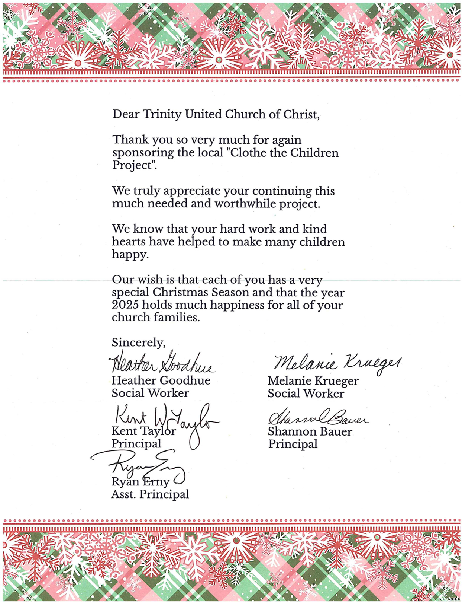



**2025 Trinity Women’s Fellowship**

**February 9, 2025** – Please join us after the worship service for a light breakfast for food and fellowship!

We are collecting items from the Dove Recovery House wish list as well as any size diapers for the Pre to 3 Program at the Dubois County Health Donation.  Items can be left in the bins in the foyer.

**March 7, 2025** - World Day of Prayer at Precious Blood Catholic Church

**March 9, 2025** - To be announced. Watch for more information in the newsletter and bulletin.

The following members are assigned as the “contact” person for the month to reach out to shut-in’s through a visit, card and/or phone call. Please consider also serving in this important ministry.

January - Visits and Contacts on your own

February - Heather Goodhue

March - Mary Ann Schroeder

April - Judy Hubster

May - Sylvia Adams

June - Heather Goodhue

July - Susan McGovren

August - Volunteer Needed

September - Jan Kalb

*(Officers: Heather Goodhue, Judy Hubster, Susan McGovren, Jan Kalb, & Sylvia Adams)*



**January Council Highlights**

|  |  |  |
| --- | --- | --- |
| **January Council Updates:** | | |
| **- Approval was given for:** | |
| **The Trinity UCC Annual Congregational Meeting will be held on Sunday, March 9th following Worship. This will also be Pastor Elisabeth’s first Sunday of Worship.** |

**The next Council Meeting will be held on February 10th at 7:00pm.**



**Worship Attendance**

**January 5th – 40**

**January 12th – 40**

**January 19th – 58**

**January 26th – 54**



**February 2025 - Worship Participants**

**February 2nd –**

**Bible Reader:** Susan McGovren

**Organist:** Sarah Sergesketter **Special Music:** Gather & Sing Choir

**Time with Young Disciples:** PastorMark McDaniel

**Media Producer:** Nichole Lechner

**Media Tech:** Kurt Heise

**Usher & Lock-up:** John & Susan McGovren

**Communion Prep:** John & Janis Schnarr

**February 9th –**

**Bible Reader:** Jim Patterson

**Organist:** Sarah Sergesketter

**Time with Young Disciples:** Heather Goodhue

**Media Producer:** Mark Blackgrave

**Media Tech:** Adam Roth

**Usher & Lock-up:** The Roth Family

**February 16th –**

**Bible Reader:** David Hubster

**Organist:** Mary Ann Weisheit

**Time with Young Disciples:** Pastor Mark McDaniel

**Media Producer:** Kurt Vonderheide

**Media Tech:** Kurt Vonderheide

**Usher & Lock-up:** David Hubster

**February 23rd –**

**Bible Reader:** Selena Vonderheide

**Organist:** Mary Ann Weisheit

**Time with Young Disciples:** Heather Goodhue

**Media Producer:** Doreen Lechner

**Media Tech:** Kurt Vonderheide

**Ushers & Lock-up:** Kurt & Selena Vonderheide

**February Birthdays**

**Name Date**



|  |  |  |
| --- | --- | --- |
| Sandra | Ferrell | 2 |
| Melissa | Hafele | 4 |
| Jema | Hafele | 4 |
| Rachael | Lindauer | 4 |
| Connie | Schmitt | 5 |
| John | Bottorff | 7 |
| Philip | Hafele | 10 |
| Jeff | Adams | 13 |
| Lisa | Schmidt | 15 |
| Curt | Brinkman | 16 |
| Kaine | Bressette | 27 |
| Ronan | Bressette | 27 |
| Kevin | Blackgrave | 28 |
| Carol | Ellis | 28 |
| Hazel | Premuda | 28 |



**February Anniversaries**

**Names Date Years**

**Sonia & Rich Klem 1/9/1982 43**

**If your name is not listed on this page and you would like it to be, please let Taylor know in the church office so she can get you added!**