**Trinity United Church of Christ**



***November 2024***



***Worship: 9:00 AM***

**-----------------------------------------------------------------------------------------**

***Update:***

**The scripture and sermon titles for November will be chosen on a weekly basis.**

**Thank you for your understanding during this time.**

**Communion: Please pick up your communion wafer & cup as you enter the sanctuary.**

**Offering: Please place your gifts in the offering box as you enter or leave worship.**

**Contact Information**

**Pastor: Mark McDaniel**

**Phone:** 812-583-3508

**Email:** [pastormark98@gmail.com](mailto:pastormark98@gmail.com)

**321 W. 8th Street … Jasper, Indiana 47546**

(Corner of Clay & 8th Street)

**Mailing Address:** P.O. Box 386 Jasper, 47547-0386

**Office Phone:** 812-482-4090

**Office Email:** ***trinityofficejasper@gmail.com***

**Office Hours:** Monday, Wednesday & Thursday

9:00am – 1:00pm & 2:00pm – 3:00pm

**Website:** htps://www.trinityjasperucc.org

**YouTube:** Trinity UCC Jasper IN

**Monthly Calendar**

**F 1** 9:00 am Mommy & Me Yard Sale

7:00 pm AA Meeting

**SU 3** 9:00 am Worship & Communion

10:15 am Search Team Meeting

**W 6** 7:00 pm AA Meeting

**F 8** 7:00 pm AA Meeting

**SU 10** 9:00 am Worship

10:15 am Women’s Fellowship

**M 11** 7:00 pm Church Council Meeting

**W 13** 7:00 pm AA Meeting

**TH 14** 12:30 pm Organ Service

**F 15** 9:30 amMommy & Me Playgroup

7:00 pm AA Meeting

**SU 17** 9:00 am Worship

10:15 am Men’s Fellowship

**M 18** *Newsletter Info Due to office.*

**T 19** 4:00 pm Sunset Extension

**W 20** *Newsletter Sent!*

7:00 pm AA Meeting

**F 22** 7:00 pm AA Meeting

**SU 24** 9:00 amWorship

**M 25** *Church office closed this week.*

**W 30** 7:00 pm AA Meeting

**TH 28** Thanksgiving Day!

**F 29** 7:00 pm AA Meeting

**SU 1** 9:00 am Worship& Communion

Pastor’s Corner

**What is Diversity?**

The UNC Gillings School of Global Public Health defines diversity as:

*“… a range of people with various racial, ethnic, socioeconomic, and cultural backgrounds and various lifestyles, experience, and interests.”*

The Department of Diversity and Inclusion at the University of Southern Florida takes it one step further, using the following definitions:

*Diversity Definitions*

*1. Diversity = being mindful of all dimensions of human differences and defining diversity in the broadest sense to mean the inclusion of all persons regardless of racial and ethnic background, nationality, gender, gender identity, sexual orientation, veteran status, religious, secular, and spiritual beliefs, ability, age, and socioeconomic status. Diversity embodies inclusiveness, mutual respect, multiple perspectives, and serves as a catalyst for change resulting in equity.*

*2. Equality = involves ensuring that every individual gets the same number of resources (identical) regardless of the differences between them.*

*3. Equity = aims to understand the needs of each individual and distribute the resources fairly. It involves giving everyone what they need to be successful.*

*4. Inclusion = the active creation and maintenance of culture, policy, and educational and business practices which celebrate diversity and recognize its value to our mission to excel as educators, employers, and community partners.*

*A. Through inclusive efforts, we seek to ensure that everyone can achieve their potential regardless of their experiences and circumstances.*

*B. Inclusion also requires diverse representation at all levels of the organization.*

Mainline denominations are beginning to recognize the importance of diversity and inclusiveness in the church. Many of them are providing training programs to coach churches in ways they might become more diverse.

I recently read the following quote:

*“During an era when religious institutions used theology and Scripture to malign and reject others, Jesus accepted and included Gentiles, the poor, the sick, women, Samaritans, Romans, children, and many others who were outcasts and oppressed. Being inclusive and affirming is the way of love – the way of Jesus.”*

- Stephen Mattson

When we, as a church, proclaim to be a diverse, accepting, and inclusive institution, what do we really mean? We have certainly made some efforts in being open to the LGBTIQA+ community. What more can we do?

My prayer is that all who call themselves followers of Jesus can learn to follow the ways of Jesus.

Pastor Mark



**Corrine Clark** *Legacy Living, 1850 IN-56, Rm. #202 (812-482-3482)*

*Jasper, IN 47546*

**Sherry Malone** *660 Rumbach Ave. Apt. #322 (812-582-2721)*

*Jasper, IN 47546*

**Claire Rohleder** *Legacy Living, 1850 IN-56, Rm. #137* *(812-482-3185)*

*Jasper, IN 47546*

**Linda Troxler** *Legacy Living, 1850 W State Rd 56, Rm. # 237 (812-556-3196) Jasper, IN 47546*

**Janice Sunderman** *Legacy Living,**1850 W State Rd 56, Rm. #134* *(812-559-0560)*

*Jasper, IN 47546*

**Shirlene Dreher** *376 St. Charles Street (812-634-1699)*

*Jasper, IN 47546*



**Pray without ceasing…**

* *Pray for ALL in need of healing; may God grant them strength and patience.*
* *Pray for those impacted by the devastations from wind, fire & water.*
* *Pray for those families and communities where the young and elderly have been killed by senseless violence in various places in our country, including children in schools, those getting groceries, and those attending worship.*
* *Pray for our military, first responders and those in law enforcement.*
* *Those confined to their homes and/or receiving ongoing medical treatment.*
* *Families grieving the loss of loved ones, family members and friends.*
* *Those who struggle financially and emotionally because they do not have enough of basic human needs, especially those in this community.*
* *Those who are awaiting answers that can change their lives.*

**If you or someone you know is in need of prayers, please let Taylor know in the church office via email or phone call.**

 **Mission Alive at Trinity**

**Adopt-A-Family:** We continue to help our Adopt-A-Family each month. Keep up the “change jar” giving and the prayers. Both make a difference!! The family appreciates everything we’ve done to help. Peace and Blessings! Collected **year-to-date:** **$892.25**

**ADOPT-A-FAMILY ACCOUNT**

**Carry-Over from 2023            $849.00**

**Donations year-to-date          $977.25**

**Monthly gifts*                         ($1017.01)**

**Balance as of 10-13-24             $809.24**

**\*Monthly gifts have been food cards and**

**help with utilities.  The family is VERY**

**appreciative of our help.**

**\*Also, thank you to an anonymous donor**

**who has supplied funds to pay three**

**months rent for this family.**

**Food Bank**

The community food bank donations for October were 92 bars of soap, 3 packages of diapers, 6 paper towels and 5 dish soaps. As always, thank you for your generous donations.



**November item: Dish Soap**

**November Mission ~ Clothe the Children!**

**Our goal is $3,000**

It’s time again for our **CLOTHE THE CHILDREN PROJECT.** You can take pride in the fact that for decades you have helped the Outreach Team provide warm winter clothes, shoes/boots, and coats to disadvantaged kids in our area.

This year the shopping date is **Sunday, November 24th at Walmart.** Again, we are allowing each recipient family to shop on their own with a list of items we like to provide and the dollar amount allotted for their children. The Outreach Team will be present to explain the process and answer any questions, as well as assist with checkout.

We rely on your lovingly given donations to fund this worthwhile mission. Envelopes can be found in the pews. Use one to place your gift in the offering plate OR you may include a check when you mail your offering. Please mark it **“Clothe the Children”** to assure it goes to the right place. Thank you in advance for sharing your blessings with those who are less fortunate.

~ The Outreach Team

Greeting cards with gift cards enclosed were mailed to our two college students, Ella and Maggie Hubster.  The Trinity Family has watched these two grow from tiny babies into young women discovering their career paths.

Thank you for your donations of $225 to our Elder Care project.  Checks were mailed to Legacy Living and St. Charles Health Care to help with purchasing activity supplies.

**2024 Trinity Women’s Fellowship**

*Motto: Let us not tire of doing good; for if we do not give up, the time will come when we will reap the harvest. - Galatians 6:9*

The purpose of this group is to unite the women of Trinity in Christian fellowship. We seek to support the congregation and the community through donations, service projects, and funeral meals. We thank all who have contributed in so many ways.

Fellowship will be at **10:15am** on the **second** Sunday of each month in the Chapel Room, unless noted otherwise.

**November 10, 2024** - Join us in making group visits to our shut-ins.

**December 7, 2024 8:00am - 12:00pm** - O’Tannenbaum Days Cookie Walk. Plan on bringing your homemade cookies and candies. This is the only fundraiser for the women’s group.

**January 12, 2025** - A representative from Dove Recovery House will be giving us an update on their program. Please consider donating some of the following items for their use: dish soap, sponges, Magic Erasers, laundry detergent, all-purpose cleaner, Clorox wipes, large and small trash bags, toilet paper, paper towels, and razors. (A complete wish list and ways to volunteer are on the Women’s Fellowship bulletin board).

**February 9, 2025** - Join us after the worship service for coffee, donuts, muffins and other breakfast treats.

**March 7, 2025** - World Day of Prayer at Precious Blood Catholic Church

**March 9, 2025** - To be announced. Watch for more information in the newsletter and bulletin.

The following members are assigned as the “contact” person for the month to reach out to shut-in’s through a visit, card and/or phone call. Please consider also serving in this important ministry.

November - Sylvia Adams April - Judy Hubster

December - Volunteer Needed May - Sylvia Adams

January - Visits and Contacts on your own June - Heather Goodhue

February - Heather Goodhue July - Susan McGovren

March - Mary Ann Schroeder August - Volunteer Needed

*(Officers: Heather Goodhue, Judy Hubster, Susan McGovren, Jan Kalb, & Sylvia Adams)*

**Trinity Women’s Guild Fellowship**

Gather with women of Trinity on November 10th after church to pair up to visit our shut-ins.



**O’ Tannenbaum Days Cookie Walk Coming Soon!**

It’s time to get the mixers out and the ovens heated! **Our annual Cookie Walk takes place on December 7th from 8:00am – 12:00pm,** as part of Jasper’s O’ Tannenbaum Days. We would love to have several dozen of your favorite cookies and a couple pounds of your favorite candy to sell at this event.

All cookies and candies will be sold by the pound. Goodies should be brought to the church kitchen between 4:00 – 6:00pm on Friday, December 6th. Please mark each item with the name of the cookie or candy and if they contain peanut butter or any type of nuts.

This is the only fundraiser the Guild has. The money raised is used for funeral meal expenses, different outreach projects and this year we made a donation to help with the work on the parsonage. Thanks for taking part in this event!

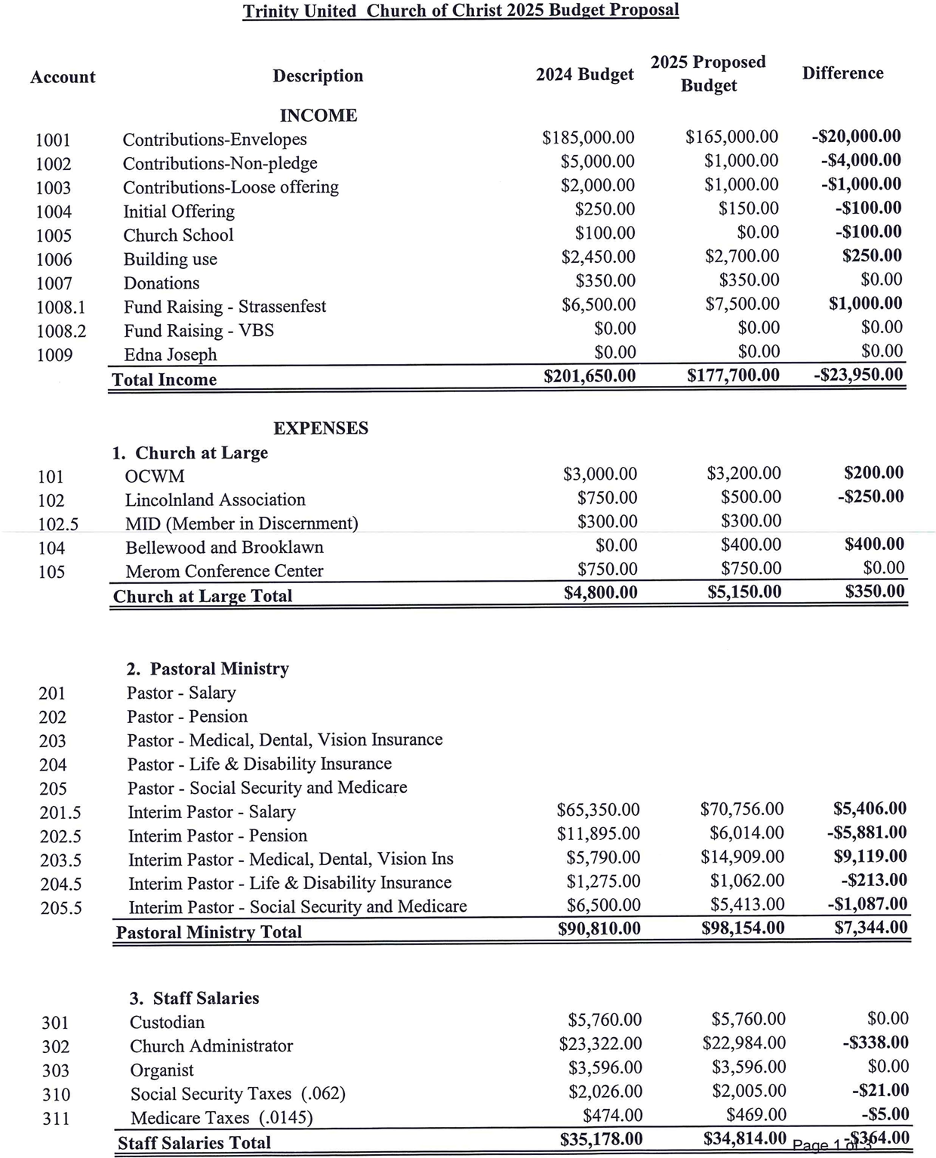

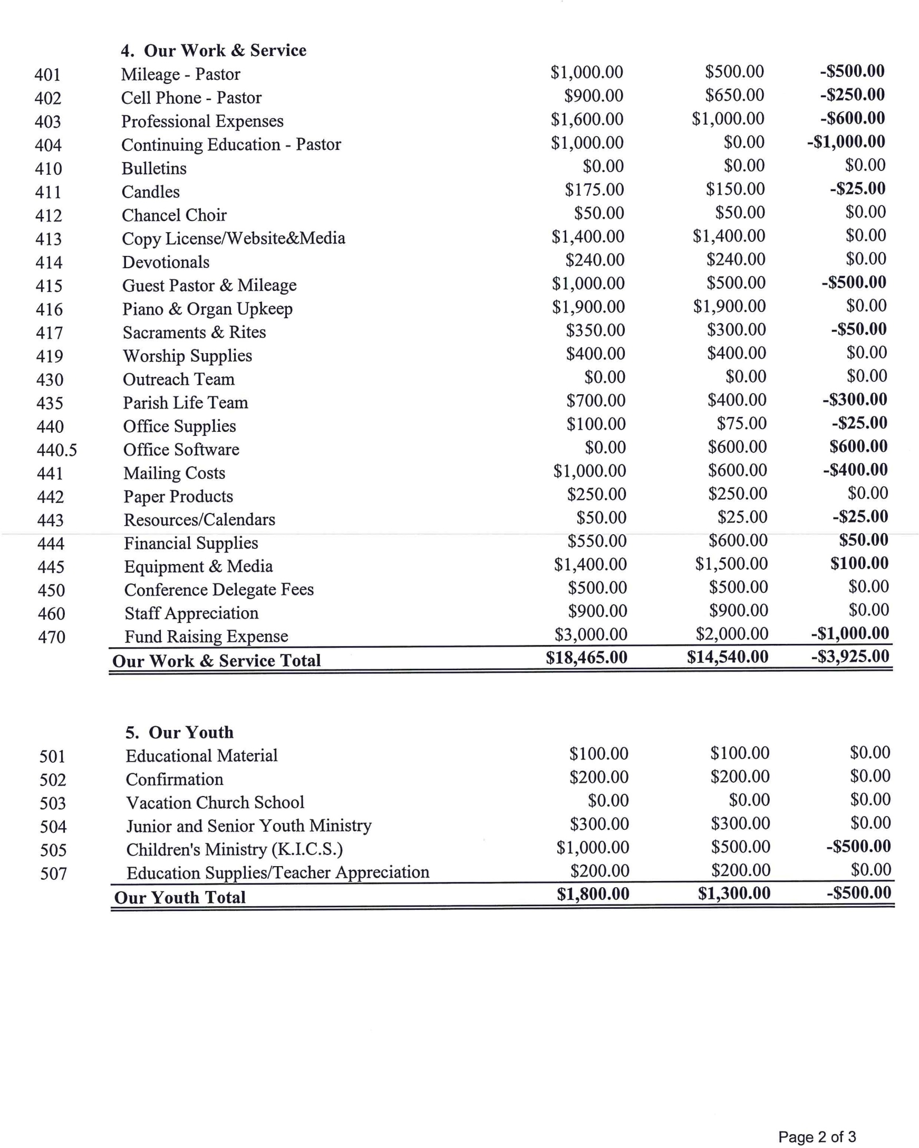

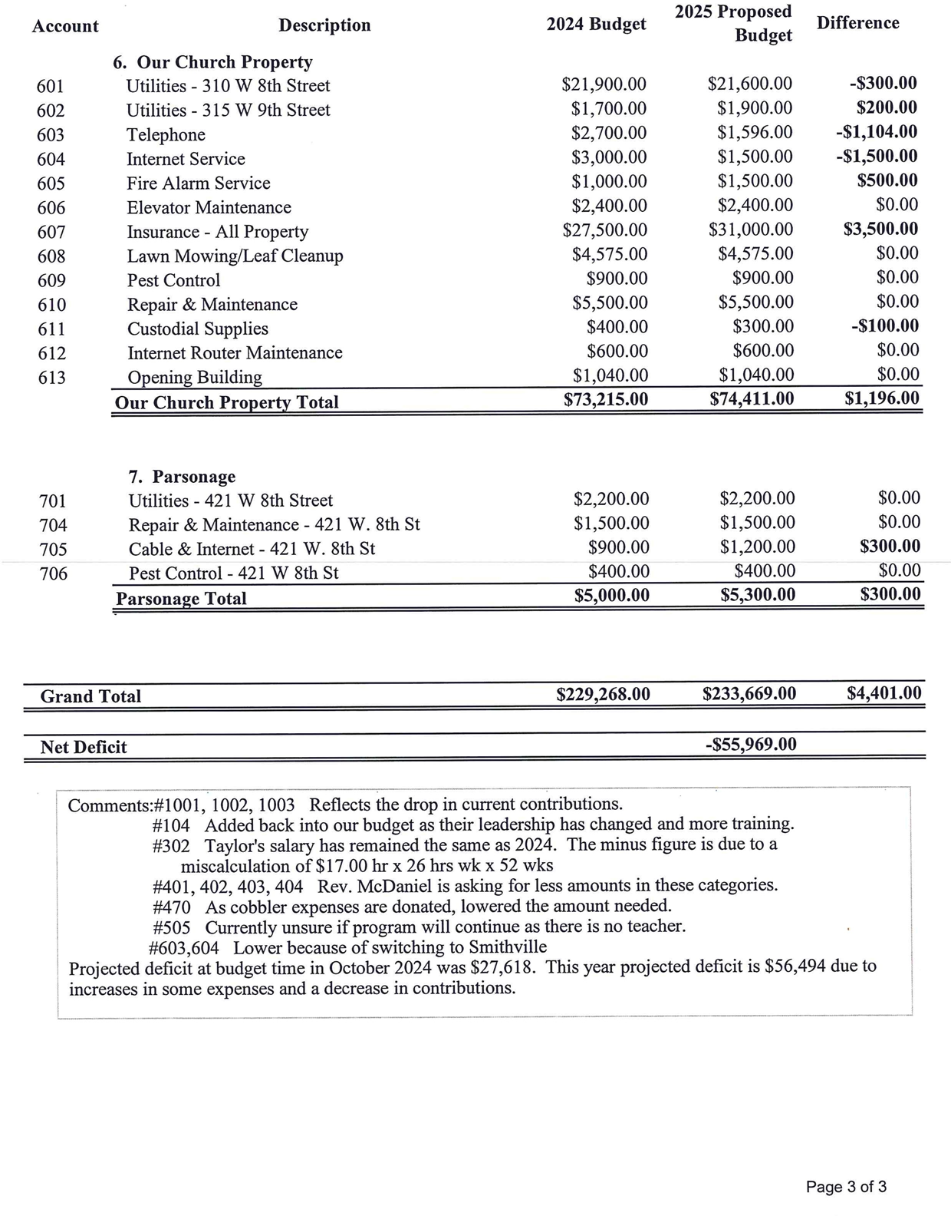

**Search Team Committee Update**

**Good News!**

Your Search Team would like to share that we have extended a call to a candidate to be our new settled Senior Pastor.

We are planning a series of sessions so you can meet the candidate. We will call this the “Candidate Weekend”. The first session will take place on Friday, November 15th with additional sessions on Saturday, November 16th.

On Sunday, November 17th, the candidate will plan, conduct and preach at our 9AM worship. Immediately after the worship service, we will have a congregational meeting. In this meeting the congregation will vote on this candidate, per our constitution we must have at least a 90% favorable vote for the candidate to become our Senior Pastor Elect.

Just a quick refresher on the United Church of Christ Search Process.

1. The search process starts with the Bridge Team; this team does the research with the congregation and the community on the needs of the church.
2. Once the Bridge Team is finished, a Search Team is formed to prepare the church profile using the information gathered from the Bridge Team.
3. The conference then takes the church’s profile and posts it so all the potential candidates can see the needs of the church.
4. When a pastor is interested in a church, the church will receive profiles from the candidates (pastors who are in a search for a new church).
5. The Search Team will then set up interviews with the candidates and then review to see if the candidate is a good match for the church.

*(Trinity’s Search Team received over 10 profiles.)*

1. Once the Search Team finds a candidate that is a match, they then extend a call to the candidate.

*In the church world we use the word “call”, instead of words like, offer or hire. A call is a special spiritual relationship between the pastor and the congregation. The congregation and the pastor enter into a series of promises and covenants.*

1. If the candidate accepts the Search Team’s call, the Search Team needs to notify the church’s leadership and the conference staff.
2. At this point the Search Team needs to hold a strict level of confidentiality, so as not to disclose the candidate’s name. The Search team needs to honor the promises and covenants the candidate currently holds with the congregation the candidate is currently serving.

*(At Trinity we would love to share the name of our candidate, but we need to wait till we are closer to the candidate weekend.)*

1. The Search Team is also charged with preparing the call papers. The candidate and Church Council should then approve the call papers. The call paper does include some legal and financial information, but is filled with promises and covenants, which guides both the pastor and congregation.

*(Trinity is currently at this step in the process.)*

1. The Search Team will plan for a candidate weekend and the trial sermon along with the congregational meeting. The candidate weekend should offer the congregation multiple opportunities to meet the candidate prior to the Worship Service.
2. After the Worship Service, the Church Council should hold a congregational meeting for a vote with a secret ballot. The votes should be counted in an open forum for all to see.
3. The Council President shall share with the congregation and the candidate the outcome of the vote, with a favorable vote the candidate becomes the Pastor Elect.

**Please look for additional information in the next couple of weeks and continue to pray for our church and our candidate.**

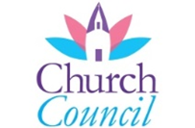

**October Council Highlights**

|  |  |  |
| --- | --- | --- |
| **October Council Decisions:** | | |
| **- Approval was given for:** | |
| **Motion to approve the proposed compensation package. Motion made by Pamela, seconded by Greg. Motion passed 6-0, with David Peters abstaining.** |

**The next Council Meeting will be held on November 11th at 7:00pm.**

**REPORT FROM THE FINANCE SECRETARY AND TREASURER**

Please consider – as of October 22

Giving to date 2023 - $151,323 (Budget was $150,078)

Giving to date 2024 - $128,796 (Budget is $155,635)

If your personal budget allows, are you able to make an extra gift?

**Worship Attendance**

** October 6th – 50**

**October 13th – 45**

**October 20th – 42**

**October 27th – 48**



**Christmas Poinsettias**

It’s that time of year again to honor or remember our friends and loved ones with the purchase of a poinsettia plant to be used in decorating our sanctuary. The price has decreased to $13 each.

Poinsettia order forms are available in the entrance, with this newsletter or attached to this email. Forms and payment may be placed in collection box outside the sanctuary doors or in the collection box outside the church office. Plants will be available to take home after the Christmas Eve service or anytime following.

**Cost is $13 per plant. All orders must be placed by Thursday, December 5th.**

Let's keep our sanctuary festive!

**Poinsettia order form - $13 each**

I/we _________________________________ would like to order __________ poinsettia plant/s for decorating of the sanctuary. Please make my donation $________________.

In memory of___________________________________________________________.

**OR / AND**

In Celebration of ________________________________________________________.

Money enclosed $___________. All orders must be placed by Thursday, December 5th.

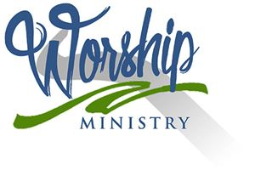

**November 2024 - Worship Participants**

**November 3rd –**

**Bible Reader:** Dean Vonderheide

**Organist:** Sarah Sergesketter **Special Music:** Gather & Sing Choir

**Time with Young Disciples:** Mark McDaniel

**Media Producer:** Nichole Lechner **Media:** Nichole Lechner

**Usher & Lock-up:** Ellen & Dean Vonderheide

**Communion Prep:** Linda Kahle

**November 10th –**

**Bible Reader:** Jim Patterson

**Organist:** Sarah Sergesketter

**Time with Young Disciples:** Heather Goodhue

**Media Producer:** Doreen Lechner **Media:** Mark Blackgrave

**Usher & Lock-up:** John & Janis Schnarr

**November 17th –**

**Bible Reader:** Susan McGovren

**Organist:** Sarah Sergesketter **Special Music:** Gather & Sing Choir

**Time with Young Disciples:** Mark McDaniel

**Media Producer:** Kurt Vonderheide **Media:** Adam Roth

**Usher & Lock-up:** Cindy Howard

**November 24th –**

**Bible Reader:** Scott Lofton

**Organist:** Sarah Sergesketter

**Time with Young Disciples:** Heather Goodhue

**Media Producer:** Mark Blackgrave **Media:** Kurt Vonderheide

**Ushers & Lock-up:** Jan & Rod Kalb

The Gather and Sing choir will sing on November 3rd and 17th. Rehearsals are in B04 at 8:40 on those Sundays. In December, we will sing on Dec 1st, 16th, and Christmas Eve. Please come and join us.

THANK YOU to all who helped sort and clean the caps/lids for the 2nd table. I could not have done 550lbs all by myself in one month! The table is ADA compliant and was delivered to the church on October 19th. We have more caps for another table and I will be in the community room for an hour or so after each service until lunch every Sunday if you feel like helping at that time. THANK YOU so much! -Sarah Sergesketter

**November Birthdays**

**Name Date**



|  |  |  |
| --- | --- | --- |
| Juliet | Adams | 2 |
| Nicole | Lechner | 2 |
| David | Stockburger | 3 |
| Corbin | Schnarr | 5 |
| Parker | Jahn | 10 |
| Addison | Schnarr | 12 |
| Geoff | Mauck | 17 |
| Ellen | Vonderheide | 17 |
| Ella | Hubster | 19 |
| Kynlie | Wright | 20 |
| Susan | McGovren | 20 |
| Bret | Astrike | 24 |
| Jeff | Eichmiller | 29 |
| Jace | Hafele | 29 |
| Jace | Brinkman | 30 |
| Kari | Roth | 30 |

**November Anniversaries**

**Names Date Years**

Kurt & Sherri Uebelhor 11/8/2008 16

Jason & Andrea Hulsman 11/13/2004 20

Greg & Dana Schnarr 11/13/2004 20

John & Janis Schnarr 11/14/1970 54

Kurt & Selena Vonderheide 11/14/1992 32

Catherine & Chris Bressette 11/15/2016 8

Inez & Dallas Knies 11/25/1961 63

**If your name is not listed on this page and you would like it to be, please let Taylor know in the church office so she can get you added!**