**Trinity United Church of Christ**



***October 2024***



***Worship: 9:00 AM***

**-----------------------------------------------------------------------------------------**

***Update:***

**The scripture and sermon titles for October will be chosen on a weekly basis.**

**Thank you for your understanding during this time.**

**Communion: Please pick up your communion wafer & cup as you enter the sanctuary.**

**Offering: Please place your gifts in the offering box as you enter or leave worship.**

**Contact Information**

**Pastor: Mark McDaniel’s**

**Phone:** 812-583-3508

**Email:** pastormark98@gmail.com

**321 W. 8th Street … Jasper, Indiana 47546**

(Corner of Clay & 8th Street)

**Mailing Address:** P.O. Box 386 Jasper, 47547-0386

**Office Phone:** 812-482-4090

**Office Hours:** Monday, Wednesday & Thursday

9:00am – 1:00pm & 2:00pm – 3:00pm

**Office Email:** ***trinityofficejasper@gmail.com***

**Website:** htps://www.trinityjasperucc.org

**YouTube:** Trinity UCC Jasper IN

**Monthly Calendar**

**T 2** 7:00 pm Outreach Meeting

**F 4** 9:00 am Mommy & Me Yard Sale

7:00 pm AA Meeting

**SU 6** 9:00 am Worship & Communion

**W 9** 7:00 pm AA Meeting

**F 11** 7:00 pm AA Meeting

**SU 13** 9:00 am Worship

10:15 am Women’s Guild

**M 14** 7:00 pm Church Council Meeting

**T 15** 4:00 pm Sunset Extension

**W 16** 7:00 pm AA Meeting

**TH 17** 10:00 am Terminix sprays

**F 18** 9:30 amMommy & Me Playgroup

7:00 pm AA Meeting

**SU 20** 9:00 am Worship

10:15 am Men’s Fellowship

**M 21** *Newsletter Info Due to office.*

**W 23** 7:00 pm AA Meeting

**F 25** 7:00 pm AA Meeting

**SU 27** 9:00 amWorship

**M 28** *November Newsletter Sent*

Time & Talent sheets are due

**T 29** 1:00 – 6:00 pm Red Cross Blood Drive (Parish Hall)

**W 30 7:00 pm AA Meeting**



**Corrine Clark** *Legacy Living, 1850IN-56, Rm. #202 (812-482-3482)*

*Jasper, IN 47546*

**Sherry Malone** *660 Rumbach Ave. Apt. #322 (812-582-2721)*

*Jasper, IN 47546*

**Claire Rohleder** *Legacy Living, 1850 IN-56,* ***Rm. #137***  *(812-482-3185)*

*Jasper, IN 47546*

**Linda Troxler** *Legacy Living, 1850 W State Rd 56, Rm. # 237 (812-556-3196) Jasper, IN 47546*

**Janice Sunderman** *Legacy Living,**1850 W State Rd 56, Rm. #134* *(812-559-0560)*

*Jasper, IN 47546*

**Shirlene Dreher** *376 St. Charles Street (812-634-1699)*

*Jasper, IN 47546*



**Pray without ceasing…**

* *Pray for ALL in need of healing; may God grant them strength and patience.*
* *Pray for those impacted by the devastations from wind, fire & water.*
* *Pray for those families and communities where the young and elderly have been killed by senseless violence in various places in our country, including children in schools, those getting groceries, and those attending worship.*
* *Pray for our military, first responders and those in law enforcement.*
* *Those confined to their homes and/or receiving ongoing medical treatment.*
* *Families grieving the loss of loved ones, family members and friends.*
* *Those who struggle financially and emotionally because they do not have enough of basic human needs, especially those in this community.*
* *Those who are awaiting answers that can change their lives.*

**If you or someone you know is in need of prayers, please let Taylor know in the church office via email or phone call.**

 **Mission Alive at Trinity**

**Adopt-A-Family:** We continue to help our Adopt-A-Family each month. Keep up the “change jar” giving and the prayers. Both make a difference!! The family appreciates everything we’ve done to help. Peace and Blessings! Collected **year-to-date:** **$892.25**

**ADOPT-A-FAMILY ACCOUNT**

Carry-over from 2023 $849.00

Donations year-to-date $889.25

Monthly gifts* ($817.01)

Balance as of 9-15-24 $921.24

*Monthly gifts have been food cards and help with utilities.

The family is very appreciative of our help.

**September Mission**

The September mission was to remember our Trinity family living in care facilities. Donations given last month will be given to the facilities to purchase needed supplies for their activity programs.

**A total of $185.00 was raised. Thanks for your continued donations!**

**Food Bank**

In the month of September our church focused on paper towels for the community food bank collection. Through the generosity of the Trinity people, we have collected 68 rolls of paper towels, 8 cans of vegetables, and one deodorant. As always, we want to thank you for the continuing support of the local food bank.



**October item: Bar Soap**

**OCTOBER MISSION - NEIGHBORS IN NEED**

Neighbors in Need is a UCC offering which supports UCC’s ministries of justice and compassion throughout the United States. Two-thirds of the offering goes towards UCC’s Love of Church Unit to fund local and national justice initiatives, advocacy efforts, and direct service projects. Neighbors in Need also supports the UCC’s council for American Indian Ministries with one-third of the offering supporting their ministry.

In 2024, the focus of Neighbor’s in Need is on mental health as a human right. Mental illnesses affect millions of people every year, but only about half receive treatment. Some of these illnesses are depression, anxiety, bipolar disorder, eating disorder, and many more. According to the CDC in 2021, suicide was the 11th leading cause of death in the United States.

The UCC believes we all have a God-given right to the following support for mental health:

1. The right to be protected from known harms to mental health.

2. The right to access quality and affordable care when a person is experiencing mental health.

3. The right to freedom and dignity, including the right of choice for mental health care.

**Our goal this year is $500.** Through your generous giving, the efforts of the UCC will continue to advocate for these mental health rights.

Isaiah 42:4

“God will not falter or lose heart until justice prevails throughout the earth.”



**September Council Highlights**

|  |  |  |
| --- | --- | --- |
| **September Council Decisions:** | | |
| **- Approval was given for:** | |
| * Motion made to enter to accept the proposed contract with Rev. McDaniel. Greg Schnarr made the motion and Pamela Catt seconded. Approved unanimously. |

**The next Council Meeting will be held on October 14th at 7:00pm.**

**REPORT FROM THE FINANCE SECRETARY AND TREASURER**

Please consider – as of September 15th

Giving to date 2023 - $134,894 (Budget was $132,924)

Giving to date 2024 - $106,794 (Budget is $137,312)

If your personal budget allows, are you able to make an extra gift?

**Worship Attendance**

** September 1st – 25**

**September 8th – 42**

**September 15th – 41**

**September 22nd – 50**

**Mommy & Me Yard Sale & Fall Event**

***\*\*date change\*\****

Friday, November 1, 2024

9:00 – 11:00 am

Set up at 8:30 am

Join us for a fun and free community event where you can sell, trade, or give away gently used children’s books, toys, games, and more. Have extra themed birthday decorations, party supplies, or baked goods? Bring them along, too!

Encourage your children to participate by letting them contribute items they no longer use, or have them create things to sell for “Mommy & Me Bucks” (or for $1 or less). They can use these bucks to shop their friend’s items or redeem prizes at the end of the event!

Activities Include:

**Pancake Breakfast**

**Pumpkin Decorating Craft**

**Table Decorating Contest**

(win a fall gift basket!)

Don’t worry; you don’t have to set up a table to participate! You and your child can come to shop, play, craft, and enjoy breakfast. If your child wants to join in, they can donate handmade cards for $1 Mommy & Me Buck each to shop other creations or trade for prizes.

RSVP by the last week of September on Evite! We can’t wait to see you there!



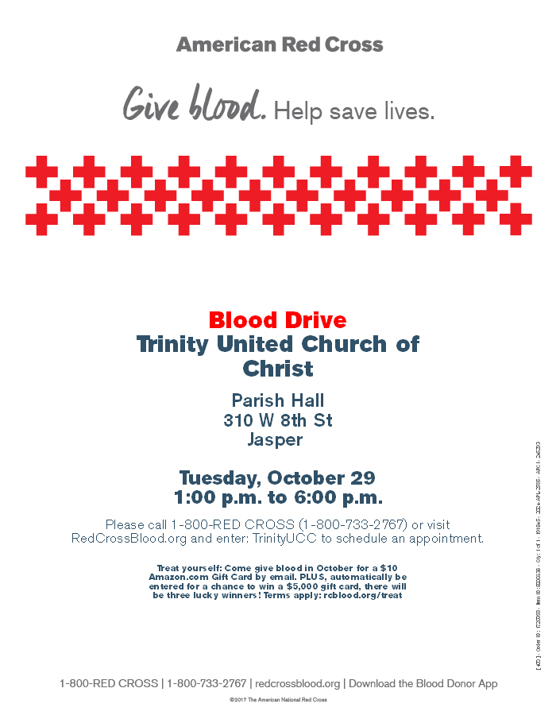

**2024 Trinity Women’s Fellowship**

*Motto: Let us not tire of doing good; for if we do not give up, the time will come when we will reap the harvest. - Galatians 6:9*

The purpose of this group is to unite the women of Trinity in Christian fellowship. We seek to support the congregation and the community through donations, service projects, and funeral meals. We thank all who have contributed in so many ways.

Fellowship will be at **10:15am** on the **second** Sunday of each month in the Chapel Room, unless noted otherwise.

**October 8, 2024**  - Women of Trinity are invited to a luncheon at the Schnitzelbank on Tuesday, October 8th at 12:00pm.  Please RSVP by October 4th to Susan McGovren at 812.631.2355 or [jsmcgovren@gmail.com](mailto:jsmcgovren@gmail.com).

**October 13, 2024** - Many hands make light work! After the worship service, come help peel apples and prepare the cobbler filling for next year’s Strassenfest!

**November 10, 2024** - Join us in making group visits to our shut-ins.

**December 7, 2024 8:00am - 12:00pm** - O’Tannenbaum Days Cookie Walk. Plan on bringing your homemade cookies and candies. This is the only fundraiser for the women’s group.

The following members are assigned as the “contact” person for the month to reach out to shut-in’s through a visit, card and/or phone call. Please consider also serving in this important ministry.

September - Jan Kalb March - Mary Ann Schroeder

October - Judy Hubster April - Judy Hubster

November - Sylvia Adams May - Sylvia Adams

December - Volunteer Needed June - Heather Goodhue

January - Visits and Contacts on your own July - Susan McGovren

February - Heather Goodhue August - Volunteer Needed

*(Officers: Heather Goodhue, Judy Hubster, Susan McGovren, Jan Kalb, & Sylvia Adams)*



**Christmas Poinsettias**

It’s that time of year again to honor or remember our friends and loved ones with the purchase of a poinsettia plant to be used in decorating our sanctuary. The price has decreased to $13 each.

Poinsettia order forms are available in the entrance, with this newsletter or attached to this email. Forms and payment may be placed in collection box outside the sanctuary doors or in the collection box outside the church office. Plants will be available to take home after the Christmas Eve service or anytime following.

**Cost is $13 per plant. All orders must be placed by Thursday, December 5th.**

Let's keep our sanctuary festive!

**Poinsettia order form - $13 each**

I/we _________________________________ would like to order __________ poinsettia plant/s for decorating of the sanctuary. Please make my donation $________________.

In memory of___________________________________________________________.

**OR**

In Celebration of ________________________________________________________.

Money enclosed $___________. All orders must be placed by Thursday, December 5th.

**Time and Talent Sheet Information**

In order for our congregation to be aware of all the areas in which individuals would like to contribute their Time and Talents in 2025, all ages are being asked to please **complete the new 2025 TIME AND TALENT SHEET.**

**There are two ways to return these forms to the Church Office:**

1. **Fill out a hard copy!** One will be included with all newsletters that were mailed to street addresses. There are also hard copies available on the credenza as you enter the building. Please put your completed copy in the offering box.
2. **Highlight your choices! A 2025** **Time and Talent Sheet** was included in the October Newsletter that was emailed to you. You may highlight and return the form to the Church Office via email.

**Please include your name and contact information!** Be sure to include everything you are willing to continue to do as well as anything you would like to start doing in 2025!

We are asking all ages of our friends and members **of our congregation to complete a form.** After the completed forms are received, we will update our records with your new information and make the list available to the various ministry teams of Trinity UCC. Thank you!

**Please have your Time and Talent sheet completed by Monday, October 28th!**

**The NEW 2025 Time and Talent Sheet Summary List will go out with the December Newsletter on November 20th!** This gives each individual plenty of time to update schedules for the New Year! The new sheets will be sent via email attached with the December Newsletter as well as placed in the back of church for pick up.



**As always, your Trinity Church Family appreciates and values you, your time and talents!**



**October 2024 - Worship Participants**

**October 6th –**

**Bible Reader:** Mary Ann Weisheit

**Organist:** Sarah Sergesketter

**Time with Young Disciples:** Mark McDaniel

**Media Producer:** Nichole Lechner **Media:** Kurt Vonderheide

**Usher & Lock-up:** Mary Ann Weisheit

**Communion Prep:** Jan & Rod Kalb

**October 13th –**

**Bible Reader:** Pamela Catt

**Organist:** Mary Ann Weisheit

**Time with Young Disciples:** Heather Goodhue

**Media Producer:** Doreen Lechner **Media:** Adam Roth

**Usher & Lock-up:** Pamela Catt

**October 20th –**

**Bible Reader:** Dan Sergesketter

**Organist:** Sarah Sergesketter

**Time with Young Disciples:** Mark McDaniel

**Media Producer:** Kurt Vonderheide **Media:** Kurt Vonderheide

**Usher & Lock-up:** David Hubster

**October 27th –**

**Bible Reader:** Selena Vonderheide

**Organist:** Sarah Sergesketter

**Time with Young Disciples:** Heather Goodhue

**Media Producer:** Mark Blackgrave **Media:** John Kahle

**Ushers & Lock-up:** Selena Vonderheide

**October Birthdays**

**Name Date**



|  |  |  |
| --- | --- | --- |
| Sarah | Blackgrave | 2 |
| Grant | Blackman | 5 |
| Chloe | Premuda | 7 |
| Julie | Beck | 7 |
| Fred | Robberts | 8 |
| Janice | Sunderman | 8 |
| Reid | Cole | 14 |
| Heather | Goodhue | 15 |
| Corma | Knebel | 15 |
| Mike | Mehling | 15 |
| Dean | Vonderheide | 15 |
| Haley | Wright | 16 |
| Vickie | Campbell | 17 |
| McKenzie | Blackman | 18 |
| Peyton | Blackgrave | 19 |
| Jerry | Adams | 21 |
| Ann | Berg | 22 |
| Brian | Meyer | 25 |

**October Anniversaries**

**Names Date Years**

Sarah & Tom Hopf 10/10/1970 53

Mike & Linda Mehling 10/11/1969 54

Jeff & Toni Miller Eichmiller 10/19/2013 10

Jeremy & Rachel Lindauer 10/25/2014 9

Kathy & Victor Danford 10/29/1988 35

**If your name is not listed on this page and you would like it to be, please let Taylor know in the church office so she can get you added!**