**Trinity United Church of Christ**



***September 2024***



***Worship: 9:00 AM***

**-----------------------------------------------------------------------------------------**

***Update:***

**The scripture and sermon titles for September will be chosen on a weekly basis.**

**Thank you for your understanding during this time.**

**Communion: Please pick up your communion wafer & cup as you enter the sanctuary.**

**Offering: Please place your gifts in the offering box as you enter or leave worship.**

**Contact Information**

**Pastor: Rev. Karen Fraser Moore**

welwoman@hotmail.com, 618.920.3592

**321 W. 8th Street … Jasper, Indiana 47546**

(Corner of Clay & 8th Street)

**Mailing Address:** P.O. Box 386 Jasper, 47547-0386

**Office Phone:** 812-482-4090

**Office Hours:** Monday, Wednesday & Thursday

9am – 1pm & 2pm - 3pm

**Office Email:** ***trinityofficejasper@gmail.com***

**Website:** htps://www.trinityjasperucc.org

**YouTube:** Trinity UCC Jasper IN

**Monthly Calendar**

**SU 1** 9:00 am Worship

**M 2 *Labor Day – Church Office Closed***

**T 3** 7:00 pm Outreach Meeting

**W 4** 7:00 pm AA Meeting

**F 6** 9:30 am Mommy & Me Playgroup

7:00 pm AA Meeting

**SU 8** 9:00 am Worship

10:15 am Women’s Fellowship

**M 9** Trinity Church gets new roof.

7:00 pmChurch Council Meeting

**W 11** 7:00 pm AA Meeting

**F 13** 7:00 pm AA Meeting

**SU 15** 9:00 am Worship

**M 16** *Newsletter Info Due to Church Office!*

**T 17** 10:00 am Dubois County Retired Teachers Meeting

4:00 pm Sunset Extension

**W 18** 7:00 pm AA Meeting

**TH 19** 10:00 am Terminix sprays

**F 20** 9:30 amMommy & Me Playgroup

7:00 pm AA Meeting

**SU 22** 9:00 am Worship

10:15 am Men’s Fellowship

**W 25** *October Newsletter Sent!*

7:00 pm AA Meeting

**F 27** 7:00 pm AA Meeting

**SU 29** 9:00 amWorship

**Church News –**

**A Year Review – 9 AM Worship**

Believe it or not, it has been 1 year since we moved from two worship services to one worship service at 9:00 AM.

The Council wants to hear from you and how the 9:00 AM worship service works for you.

We don’t believe we are in the position to move back to two worship services at this time.

We also want to look at ways to support Christian educational opportunities on Sunday morning.

So, let us know, should we continue with our 9:00 AM worship or do we move the time?

You can fill out the “Green Comment” card, with your thoughts, your name needs to be included, and then drop the card in the offering box.

You can also comment via email, [trinityofficejasper@gmail.com](mailto:trinityofficejasper@gmail.com)

**Update On Our Next Transitional Interim Pastor and the Search for a Settled Pastor**

The Council recognizes some anxiety over who will be our next pastor.  The council is also asking everyone to stay faithful during all these transitions.

During the month of September, we are working on finding Supply Pastors and planning informational / inspirational worship services.

Rev. Mark McDaniel has agreed to become our next Transitional Interim Pastor.  Mark’s start time is still being finalized.  Mark is serving the Evangelical UCC in Tell City. Like Rev. Karen Fraser-Moore, Mark is trained in serving churches in transitions as the church searches for a Settled Pastor.  You will find out more about Mark in the next couple of weeks.

In the event of a pastoral need please reach out to one of the Council leaders.  We have several pastors who are willing to help if we have a funeral during our pastoral vacancy.

The Search Team continues to wait for the right person to be our next Settled Pastor.  Like in the secular job market, finding the correct candidate can be a long process. Especially since the number of pastors looking for churches is very limited.  The Search Team asks that you pray for our next pastor to reveal herself or himself to us.



**Corrine Clark** *Legacy Living, 1850IN-56, Rm. #202 (812-482-3482)*

*Jasper, IN 47546*

**Sherry Malone** *660 Rumbach Ave. Apt. #322 (812-582-2721)*

*Jasper, IN 47546*

**Claire Rohleder** *Legacy Living, 1850 IN-56,* ***Rm. #137***  *(812-482-3185)*

*Jasper, IN 47546*

**Linda Troxler** *Legacy Living, 1850 W State Rd 56, Rm. # 237 (812-556-3196) Jasper, IN 47546*

**Janice Sunderman** *Legacy Living,**1850 W State Rd 56, Rm. #134* *(812-559-0560)*

*Jasper, IN 47546*

**Shirlene Dreher** *376 St. Charles Street (812-634-1699)*

*Jasper, IN 47546*



**Pray without ceasing…**

* *Pray for ALL in need of healing; may God grant them strength and patience.*
* *Pray for those impacted by the devastations from wind, fire & water.*
* *Pray for those families and communities where the young and elderly have been killed by senseless violence in various places in our country, including children in schools, those getting groceries, and those attending worship.*
* *Pray for our military, first responders and those in law enforcement.*
* *Those confined to their homes and/or receiving ongoing medical treatment.*
* *Families grieving the loss of loved ones, family members and friends.*
* *Those who struggle financially and emotionally because they do not have enough of basic human needs, especially those in this community.*
* *Those who are awaiting answers that can change their lives.*

**If you or someone you know is in need of prayers, please let Taylor know in the church office via email or phone call.**

******Mission Alive at Trinity**

**Adopt a Family:** We continue to help our Adopt-A-Family each month. Thanks to your generosity, so far this year we have paid their rent for 2 months and provided 4 Ruler gift cards for groceries. Keep up the “change jar” giving and the prayers. Both make a difference!! The family appreciates everything we’ve done to help. Peace and Blessings!

**Year-to-date** we have collected **$307.25**

**Food Bank**

In the month of August our church focused on cereal for the community food bank collection. Through the generosity of the Trinity people, we have collected 16 boxes of cereal. As always, we want to thank you for the continuing support of the local food bank.



**September item: Paper Towels**

**SEPTEMBER’S MISSION**

Usually in September we collect for our College Care Project. However, this year we only have two college age members, Ella and Maggie Hubster. Of course, we will continue to reach out to them with funds that have already been given.

Therefore, we would like to remember our Trinity family living in care facilities. Donations given this month will be given to the facilities to purchase needed supplies for their activity programs. Envelopes for your kind donations can be found in the Narthex. **Our goal is $500**

**Parents Supporting Education Thanks YOU!**



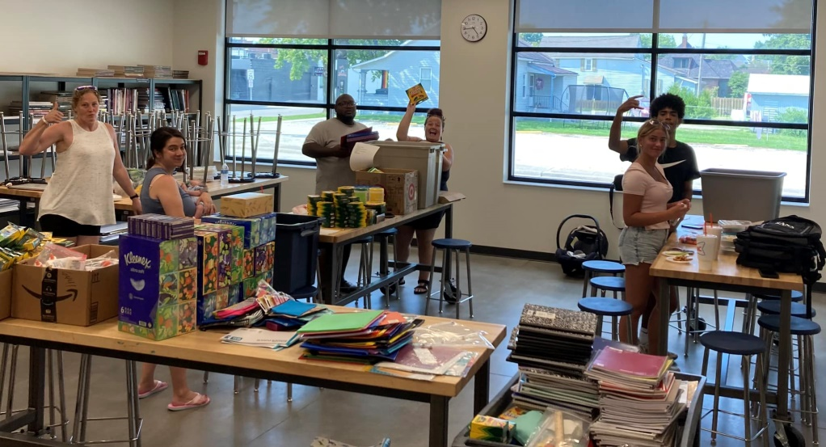



**August Council Highlights**

|  |  |  |
| --- | --- | --- |
| **August Council Decisions:** | | |
| **- Approval was given for:** | |
| * Motion made to enter into agreement with Mark McDaniels pending final negotiations by Greg Schnarr and seconded by Doreen Lechner. Motion carried unanimously. |

**The next Council Meeting will be held on September 9th at 7:00pm.**

**Summary of Strassenfest Booth Financials 2024**

Despite the heat and threat of rain, people came out to the Strassenfest and found our new location tucked into the corner of the square. Our gross sales for the 3 days we were open were $7,208. After paying 15% of that to the Strassenfest Committee and paying our other expenses, our net profit amounted to $5,408. Virtually all the cobbler ingredients were donated by members of our church. Without that, our numbers would be down quite a bit. I want to thank all who donated ingredients and/or time to the project. Many went beyond the call of duty. Once again, our church pulled together.

~Pamela Catt – 2024 Strassenfest chair

**Worship Attendance**

** August 4th – 53**

**August 11th – 37**

**August 18th – 38**

**August 25th – 50**





**Grief Support Series**

Memorial Hospital and Healthcare Grief Support Series is a 25-year program offered to those who have suffered a significant loss of a loved one, a child leaving home, a divorce, a healthcare issue, or some other overwhelming change in one’s life.

Our fall program begins on Tuesday evening, September 10th and will meet from 6:00pm – 8:00pm Eastern Time in the hospital chapel. The dates are September 10th, 17th and 24th as well as October 1st and 8th.

There is no charge for this program.

We recommend reservations by calling the Pastoral Care Department at the hospital 812-996-0219. Reservations fill up quickly.

Those who facilitate are Dr. Tom Holsworth, Clinical Pathologist, and Theresa O’Bryan, Hospital Chaplin and private Spiritual Director.

Please call 812-639-2427 if you have any questions. Thank you.



**Many Hands make light work!**

I have a project that I would like to invite the whole church to get involved in. As many of you might know, people have been collecting plastic caps and lids for Merom for quite a while to make benches and tables for Camp. Well, they are offering the caps and lids to churches to get benches and tables for their use. I would like to replace the OLD wooden tables on the concrete pad by the alley with 4 tables that will look nice and last for a long time. I need 1500 lbs to get 3 more tables made. It is an easy job to sort clean from those that are dirty and need to be washed. Ages 4- 94 can do this!

I would like to have an “All Hands on Deck” day at Trinity after the church service on Sunday, September 22nd to sort through the bags. We can sit and talk with each other at the tables as we sort. I will be there to give you help and information on what to do. If anyone can stay for an hour or more I would really appreciate it. You can leave for lunch anytime and come back if you want. If you want to eat lunch at church, that would be fine, too. I plan on staying until 3:00pm and take the dirty caps home to be washed. If anyone would like to do that at home, too, that would be great!

I hope to see many of you there. It is not hard work; just time consuming, especially for only 1 or 2 people to do it. I will also be at church on September 29th and October 6th if those dates suit you better. THANK YOU!

~ Sarah Sergesketter

Dear Trinity Family,

I wanted to thank my church family for the generous donation towards my 2024 Wyldlife Camp at Timber Wolf Lake in Michigan this past summer. I feel blessed to have experienced another wonderful week sharing my love for Christ with other faithful friends. The Wyldlife journey is one I will never forget and look forward to continuing as the year’s progress to Young Life.  What an amazing GOD we have and what an amazing church family I have.

Thank you,

Karsen Roth

**2024 Trinity Women’s Fellowship**

*Motto: Let us not tire of doing good; for if we do not give up, the time will come when we will reap the harvest. - Galatians 6:9*

The purpose of this group is to unite the women of Trinity in Christian fellowship. We seek to support the congregation and the community through donations, service projects, and funeral meals. We thank all who have contributed in so many ways.

Fellowship will be at **10:15am** on the **second** Sunday of each month in the Chapel Room, unless noted otherwise.

**September 8, 2024** - Our own Mayor Dean Vonderheide will be sharing information about the Mayor’s Youth Council. He will talk about why he started it, how members are selected etc. Please pick up an extra copy of this year’s meeting schedule from the credenza. Remember, all women of Trinity are welcome at our meetings!

During the month of September, we will also be sponsoring a diaper drive for the Dubois Co Health Department Pre to 3 Program. They will accept any size diapers, wipes, and baby blankets to encourage tummy time. We will hear more about this program at our April gathering.

**October 8, 2024**  - Any interested Women of Lincolnland can meet for lunch at noon at the Schnitzelbank.

**October 13, 2024** - Many hands make light work! Come help peel apples and prepare the cobbler filling for next year’s Strassenfest.

**November 10, 2024** - Join us in making group visits to our shut-ins.

**December 7, 2024 8:00am - 12:00pm** - O’Tannenbaum Days Cookie Walk. Plan on bringing your homemade cookies and candies. This is the only fundraiser for the women’s group.

The following members are assigned as the “contact” person for the month to reach out to shut-in’s through a visit, card and/or phone call. Please consider also serving in this important ministry.

September - Jan Kalb March - Mary Ann Schroeder

October - Judy Hubster April - Judy Hubster

November - Sylvia Adams May - Sylvia Adams

December - Volunteer Needed June - Heather Goodhue

January - Visits and Contacts on your own July - Susan McGovren

February - Heather Goodhue August - Volunteer Needed

*(Officers are Heather Goodhue, Judy Hubster, Susan McGovren, Jan Kalb, and Sylvia Adams)*



**September 2024 - Worship Participants**

**September 1st –**

**Bible Reader:** Sabrina Peters

**Organist:** Sarah Sergesketter

**Media Producer:** Mark Blackgrave **Media:** Adam Roth

**Usher & Lock-up:** Kurt Vonderheide

**September 8th –**

**Worship Leader:** Rev. Deborah McBride

**Bible Reader:** David Hubster

**Organist:** Mary Ann Weisheit

**Media Producer:** Nichole Lechner **Media:** Kurt Vonderheide

**Usher & Lock-up:** David Hubster

**September 15th –**

**Worship Leader:** Rev. Deborah McBride

**Bible Reader:** Doreen Lechner

**Organist:** Heather Goodhue **Special Music:** James Goodhue

**Time with Young Disciples:** Heather Goodhue

**Media Producer:** Doreen Lechner **Media:** John Kahle

**Usher & Lock-up:** Heather Goodhue

**September 22nd –**

**Bible Reader:** Shelley Patterson

**Organist:** Sarah Sergesketter **Time with Young Disciples:** Heather Goodhue

**Media Producer:** Kurt Vonderheide **Media:** Nichole Lechner

**Ushers & Lock-up:** Larry LaGrange

**September 29th –**

**Bible Reader:** Kaiden Roth

**Organist:** Sarah Sergesketter **Special Music:** Gather & Sing Choir

**Time with Young Disciples:** Heather Goodhue

**Media Producer:** Mark Blackgrave **Media:** Mark Blackgrave

**Ushers & Lock-up:** Susan McGovren

**THANK YOU to Glory Bound Singers and their accompanists for the special music in August!**

**September Birthdays**

**Name Date**



|  |  |  |
| --- | --- | --- |
| Tim | Hafele | 5 |
| Jerry | Thom | 6 |
| Bentley | Lindauer | 7 |
| Jack | Rumbach | 10 |
| Laurel | Hubster | 12 |
| Mark | Hopster | 15 |
| Shea | McGovren | 16 |
| Audra | Jahn | 17 |
| Gerald | Knebel | 17 |
| Hannah | Schnarr | 18 |
| Paula | Marshall | 19 |
| Angie | Hobson | 20 |
| Reid | Lindauer | 20 |
| Ruth | Coller | 25 |
| John | Coller | 29 |
| Greg | Schnarr | 30 |

**September Anniversaries**

**Names Date Years**

Christine & Daniel Dodd 9/3/1983 40

Mark & Cheryl Hopster 9/6/1987 36

Megan & Josh Premuda 9/8/2012 11

Josh & Sarah Blackgrave 9/16/2017 6

David & Sabrina Peters 9/23/1995 28

David & Stacy Hubster 9/26/1998 25

**If your name is not listed on this page and you would like it to be, please let Taylor know in the church office so she can get you added!**